EXPERIMENT-1

ROLL NO:240701262 NAME:P.KEVINBHARATH

USER INTERFACE AND DESIGN

BAD WEBSITE:
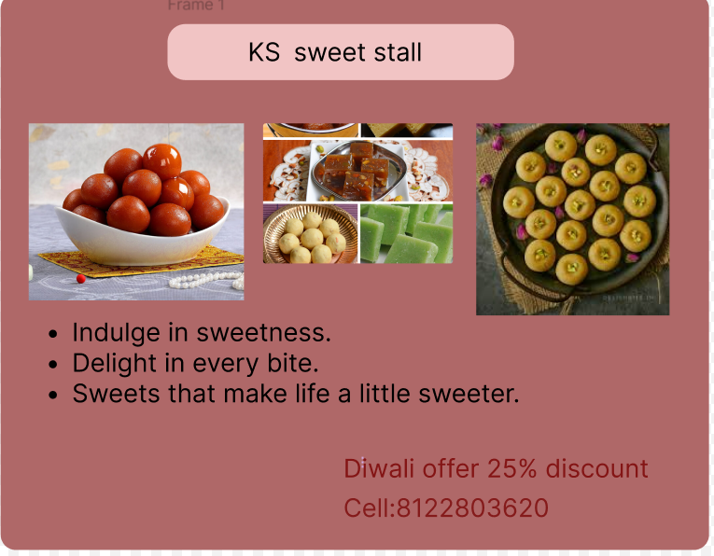

GOOD WEBSITE:

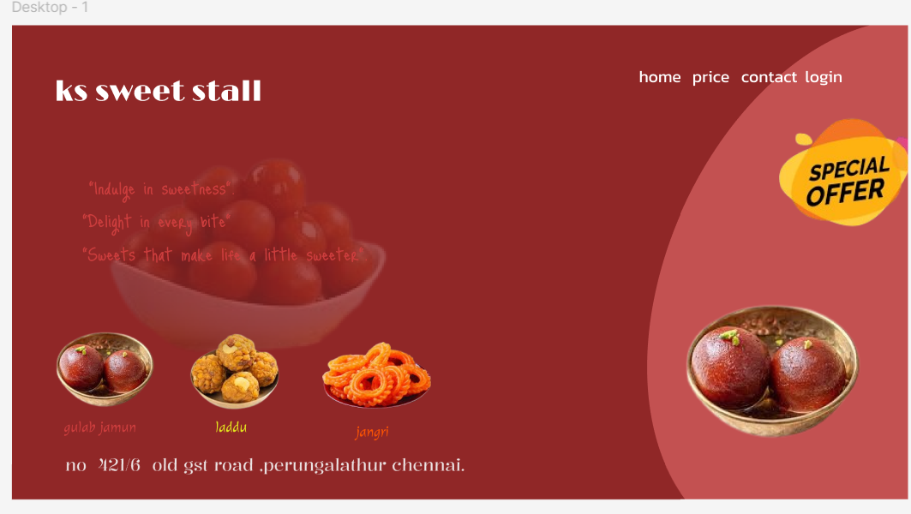
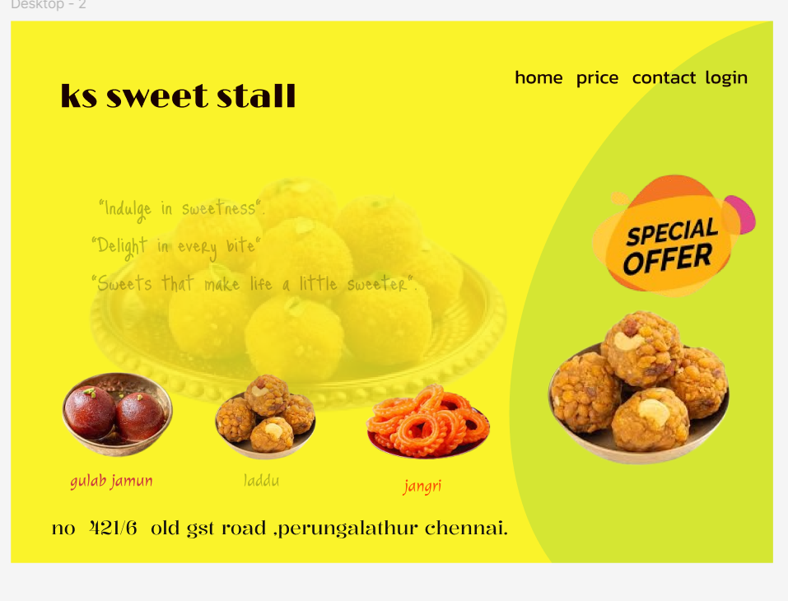
https://www.figma.com/design/QNwaxT3g95PPu0oebd0LAM/Untitled?node-id=0-1&t=SXJs3Sakbcf5phlA-1
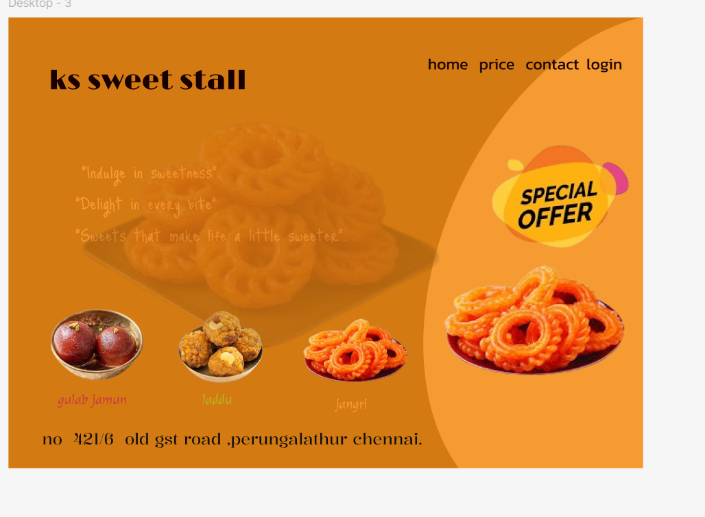

Good Design (Example: Improved Sweet Stall Poster)
Features
✔ Clear shop name at top
✔ Limited color palette (2–3 matching colors)
✔ High-quality sweet images
✔ Proper spacing and alignment
✔ Easy-to-read font
✔ Offer highlighted clearly
✔ Contact number visible
Why it is good
- Easy to understand in 5 seconds
- Professional look
- Attractive to customers
- Improves sales chances
Result
Customers quickly notice Diwali Offer – 25% Discount and contact details.

Bad Design (Example: Poor Poster)
Features
✖ Too many bright colors
✖ Cluttered images
✖ Small or unreadable text
✖ No proper alignment
✖ Different fonts everywhere
✖ Offer hidden or unclear
✖ Too much information
Why it is bad
- Confusing layout
- Hard to read
- Looks unprofessional
- Customers lose interest
Result
Customers ignore the poster and miss the offer.

___________________________________________________

Comparison Table
Factor | Good Design | Bad Design
Colors | Limited & matching | Too many & harsh
Fonts | 1–2 clean fonts | Many random fonts
Layout | Organized | Messy
Images | Clear & few | Crowded
Message | Simple & clear | Confusing
Attraction | High | Low

Conclusion
Good design improves:
- Visibility
- Communication
- Customer engagement
- Business sales
Bad design reduces readability and customer interest.

https://www.figma.com/design/QNwaxT3g95PPu0oebd0LAM/Untitled?node-id=0-1&t=SXJs3Sakbcf5phlA-1

____________________________________________________

